Use-Case Realization Report (Requirements)
Change State

Issue 3.0
Revision History
Date | Issue | Description | Author
19 July 2000 | 1.0 | First Issue | Howard Russon
18 July 2001 | 2.0 | Revised for MTech Unit 3 in 2001 | Howard Russon
22 July 2004 | 3.0 | Revised for MTech Unit 3 in 2004 | Howard Russon

Table of Contents
1. Brief Description 4
2. Flow of Events 4
2.1 Standard Flow 4
2.2 Exceptions 4
3. Interaction Diagrams 5
3.1 Domain Collaboration Diagram: Change State 5
4. Participating Objects 5
5. Class Diagrams 6
5.1 Domain Class Diagram: Change State 6
6. Derived Requirements 6

Use-Case Realization Report
Change State

Brief Description
This use case enables the Controller to perform the physical activities that the Maintainer would perform in the target implementation. Using the Machinery Simulator Panel, the Controller will be able to change the stock level for each brand or coin denomination, and to lock the vending machine door.

Flow of Events
The standard flow of events for this use case and any exceptions are described in the following subsections. See section 3.1 for an overview of the participating Actors and Domain Objects.

Standard Flow
This use case provides the simulation of the physical activities undertaken by the Maintainer (in the real vending machine) to re-stock the vending machine. In the simulation, these activities will be undertaken by the Controller using a computer user interface (Machinery Simulator Panel). For the Machinery Simulator Panel to be useable, the Maintainer should log-in to the Maintenance Panel. On successfully logging-in, the vending machine door status is changed to unlocked and the Machinery Simulator Panel is activated for data entry. The following facilities are then available:
- The Machinery Simulator Panel will display the number of cans of each Drinks Brand that are physically in the vending machine's Drinks Store, and the Coins of each denomination that are physically in the vending machine's Cash Store.
- The Controller will be able to type over any of these current values to specify new stock levels.
- On changing the stock levels on the Machinery Simulator Panel, the stock levels in the machine will change accordingly.
- This facility will also allow the Controller to lock the vending machine Door by checking the “Door Locked” checkbox.
- On changing the door state on the Machinery Simulator Panel, the simulated state of the vending machine’s door will change accordingly.

Exceptions
The following exceptions have been identified:
- Door is Locked. If the vending machine door is locked (ie: the Maintainer has not logged-in to the Maintenance Panel) then the Machinery Simulator Panel will display current stock levels and the Door status, but will not permit the Controller to make any changes to any of these values. The Door can only be opened by the Maintainer logging in to the Maintenance Panel.
- Valid Ranges. When the Controller enters new stock levels, the valid ranges will be as follows:
- Coins of each denomination must be a non-negative integer, less than or equal to 40.
- Cans of each Drinks Brand must be a non-negative integer, less than or equal to 20.

Interaction Diagrams

Domain Collaboration Diagram: Change State
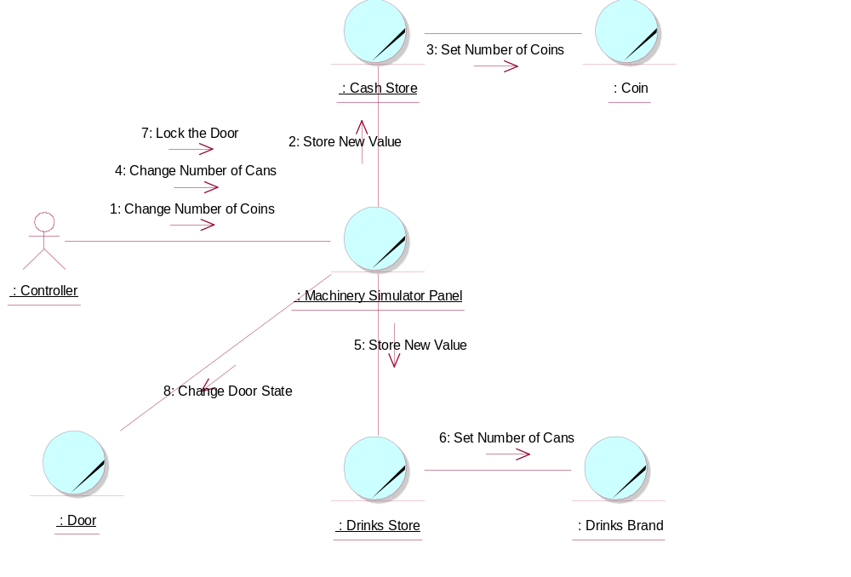

Participating Objects
: Cash Store
This is the repository for all Coins entered into the system. It is also where all change given to the Customer is taken from.
: Coin
The object stores the characteristics of coins entered into the system.
: Controller
This actor represents the controller of the VMCS simulation. Hence it is only present in the simulated system (ie: this project) and would not be an actor of the target implementation. In particular, it performs several of the physical activities (ie: those that can not be provided by software) that are undertaken by the Maintainer in the target implementation, which include maintaining drink stocks and cash stocks inside the vending machine.
: Door
This is the door of the vending machine. This is opened so that the Maintainer can re-stock the machine.
: Drinks Brand
This object stores the characteristics of the types of drinks can held in the system.
: Drinks Store
This is the repository for the drinks cans held by the system.
: Machinery Simulator Panel
This panel simulates the physical actions of the maintainer. It enables the user to:
1 display and enter new values for the number of cans of each Drinks Brand held by the Drinks Store;
2 display and enter new values for the number of Coins of each denomination held by the Cash Store;
3 display whether the vending machine Door is unlocked, and enable it to be locked.

Class Diagrams

Domain Class Diagram: Change State
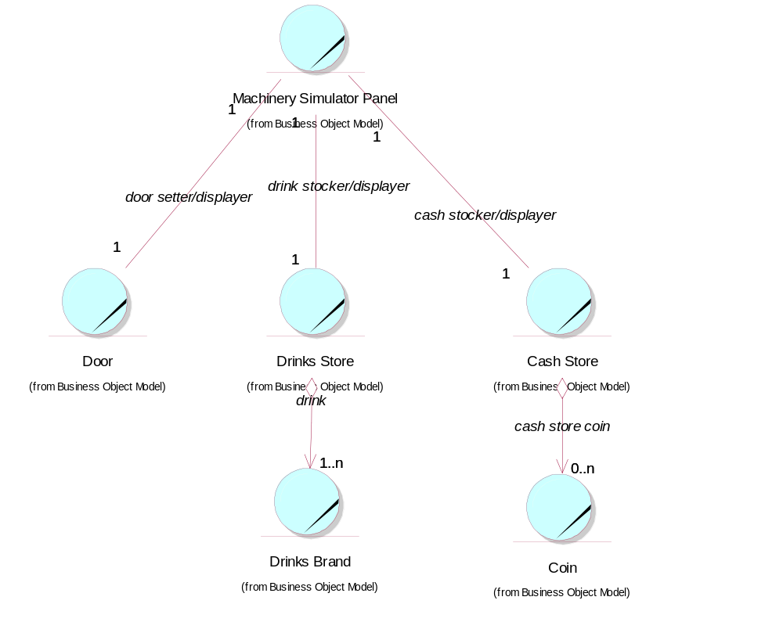

Derived Requirements
No special requirements have been identified.

